**EECS 392: FPGA Systems Design Projects – Project Plan**

*Team Name*

*Team Members*

* Jason Arkin
* Ian Feeney
* Sebastian Rodriguez
* Spencer Williams
* Sebastian Witkowski

*Project Title*

JS3Inth

*Project Description / Overview*

JS3Inth is an 18-key synthesizer with multiple synth modulations and state volume control implemented in real-time. This project will be implemented in the Cyclone IV EP4CE115F29C7N field programmable gate array (FPGA). Each switch, from left to right, will be mapped to a particular frequency corresponding to notes on a traditional keyboard format, expanding through an octave and a half. The user will be able to cycle through several ranges of frequencies which represent octaves in a traditional keyboard. We will also allow the user to switch between multiple forms of sound modulation through a button input that will cycle through various programmed sound textures. Also included is a mute button that provides the option to silence the system. In addition to this functionality, we will be also implementing a graphics user interface (GUI) which will be outputted through a video-graphics array (VGA).

*System Architecture / IO / Peripherals / Memory*

All inputs and outputs are sent through FIFO buffer to preserve the integrity of the signals. Initially, we have 18 switch inputs which are connected to a read-only memory (ROM). Each switch input will correspond to a point in memory which will then be outputted to a frequency adder. Additionally, we will be multiplying the output of the frequency adder by a certain amount determined by the state of the octave state machine.

A finite state machine is implemented to determine the current synthesizer being used. Once a certain synth has been decided, the correct function inputs are pulled from the ROM and put into the synth modulation block, which combines with the frequency adder outputs to create a modified audio wave.

The volume is controlled through a finite state machine that cycles through 5 levels, these levels determine the maximum amplitude of the output signal. The output signal of the synth modulator is multiplied is multiplied to increase the amplitude until it hits the correct volume. This signal is sent to the Line Out module to the user’s speakers. The mute button toggles the Line Out module on and off.

All inputs are also passed through our VGA module, which reads the inputs and displays a simple user interface to help the user keep track of any of the keys, volumes, and octaves running in the system.

*Block Diagram*

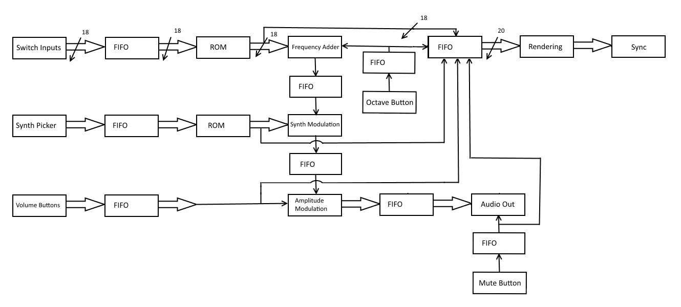

*Tasks / Gantt Chart*

Spencer

*Members Responsibilities*

* VGA Module – Rodriguez
* Synthesizer Module – Arkin, Feeney, Williams
* I/O Module – Witkowski

*Development Plan*

Spencer

*Deliverables*

* Working FPGA synthesizer
* Final Report

*Project Costs*

Spencer